**Pizza sales SQL queries**

1. **KPI’s**

**a)Total revenue:**

**select sum(total_price) from pizza_sales;**

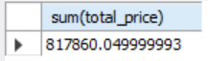

**b)Average order value:**

**select sum(total_price) / count(distinct order_id) from pizza_sales;**

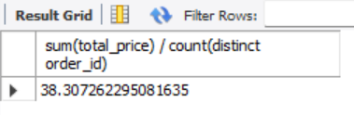

**c)Total pizzas sold**

**select sum(quantity) from pizza_sales;**

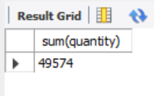

**d) Total orders placed :**

**select count(distinct order_id) from pizza_sales;**

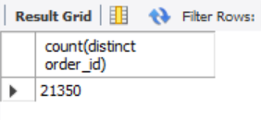

**e) Average pizzas per order :**

**SELECT**

**CAST(SUM(quantity) AS DECIMAL(10, 2)) /**

**CAST(COUNT(DISTINCT order_id) AS DECIMAL(10, 2)) FROM pizza_sales;**

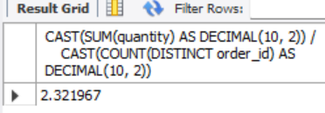

1. **Chart -01 (Daily Trend for total orders)**

SELECT

order_day,

COUNT(DISTINCT order_id) AS total_orders

FROM (

SELECT

order_id,

DAYNAME(STR_TO_DATE(order_date, '%d-%m-%Y')) AS order_day

FROM pizza_sales

WHERE order_date IS NOT NULL

) AS converted

GROUP BY order_day

ORDER BY total_orders DESC;

1. **Chart- 02 (Monthly trend for orders)**

SELECT

order_month,

COUNT(DISTINCT order_id) AS total_orders

FROM (

SELECT

order_id,

monthname(STR_TO_DATE(order_date, '%d-%m-%Y')) AS order_month

FROM pizza_sales

WHERE order_date IS NOT NULL

) AS converted

GROUP BY order_month

ORDER BY total_orders DESC;

1. **Chart -03 (% of sales by pizza category)**

SELECT

ps.pizza_category,

cSUM(ps.total_price) * 100 / ts.total_sales AS percentage_sales

FROM

pizza_sales ps

JOIN

(SELECT SUM(total_price) AS total_sales FROM pizza_sales) ts

GROUP BY

ps.pizza_category;

1. **chart-04 (% of sales by pizza size)**

SELECT

ps.pizza_size,

cast(SUM(ps.total_price) * 100 / ts.total_sales as decimal(10,2)) AS percentage_sales

FROM

pizza_sales ps

JOIN

(SELECT SUM(total_price) AS total_sales FROM pizza_sales) ts

GROUP BY

ps.pizza_size

order by percentage_sales desc;

1. **chart- 05 ( Total pizza sold by pizza category)**

SELECT pizza_category, SUM(quantity) as Total_Quantity_Sold

FROM pizza_sales

GROUP BY pizza_category

ORDER BY Total_Quantity_Sold DESC;

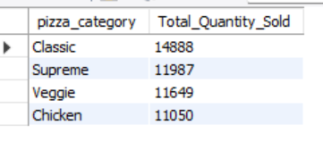

1. **chart- 06 (Top 5 pizzas by revenue)**

SELECT pizza_name, SUM(total_price) AS Total_Revenue

FROM pizza_sales

GROUP BY pizza_name

ORDER BY Total_Revenue DESC limit 5;

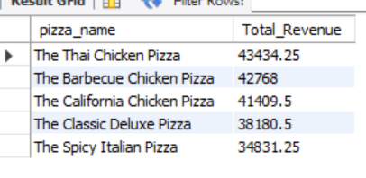

1. **chart-07 ( Bottom 5)**

SELECT pizza_name, SUM(total_price) AS Total_Revenue

FROM pizza_sales

GROUP BY pizza_name

ORDER BY Total_Revenue asc limit 5;

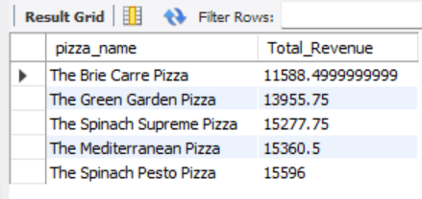

1. **chart – 08 ( Top 5 pizza by quantity)**

SELECT pizza_name, SUM(quantity) AS Total_sold

FROM pizza_sales

GROUP BY pizza_name

ORDER BY Total_sold desc limit 5;

1. **chart – 09 ( Bottom 5 by quantity)**

SELECT pizza_name, SUM(quantity) AS Total_sold

FROM pizza_sales

GROUP BY pizza_name

ORDER BY Total_sold asc limit 5;

1. **chart – 10 ( Top 5 pizza by total orders )**

SELECT pizza_name, COUNT(DISTINCT order_id) AS Total_Orders

FROM pizza_sales

GROUP BY pizza_name

ORDER BY Total_Orders DESC limit 5;

1. **chart – 11 ( bottom 5 pizza by total orders )**

SELECT pizza_name, COUNT(DISTINCT order_id) AS Total_Orders

FROM pizza_sales

GROUP BY pizza_name

ORDER BY Total_Orders ASC limit 5;